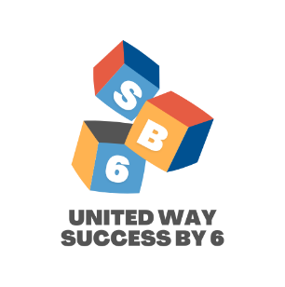
Family Survey
Thank you for allowing your child to participate in the Pre-K Summer Program. We hope that you find it to be a worthwhile experience for your child. Please fill out the survey below and return it to your teacher as soon as possible. We welcome your feedback about our program.

- My child improved in reading and math. Yes No

- My child improved in social skills and responsibility Yes No

- I was pleased with the overall Pre-K summer program Yes No

- My child will be better prepared for the school year. Yes No

- My child enjoyed coming to Success By 6. Yes No

Please share an example of the progress that your child made provided by our Success By 6 program. _____________________________________________________

Do you have any other thoughts or suggestions that you may have for our future Success By 6 programs? ______________________________________________________________________

- Has your child participated in our Dolly Parton Imagination Library program that sends free books to your home in your son or daughter’s name?

Please circle: YES NO

