

Kindergarten
Assessment

2025

Colors

Shapes

Lowercase Letter Recognition

s | t | c | f | g | b
v | n | h | o | m | x | d
p | u | z | a | e | i | k
r | l | j | y | w

Uppercase Letter Recognition

S | T | C | F | G | B | Q
V | N | H | O | M | X | D
P | U | Z | A | E | I | K
R | L | J | Y | W

Number Recognition

2 | 7 | 5 | 9 | 10
 | 1 | 8 | 3 | 6

Rhyming

Example:   | 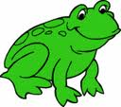  

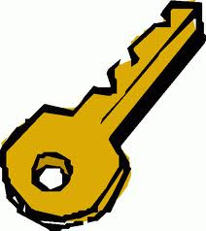 | 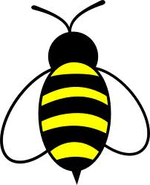  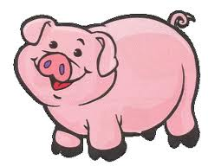
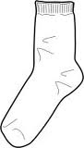 | 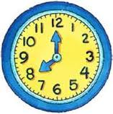  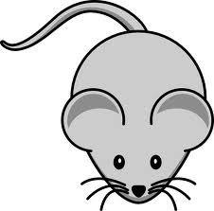
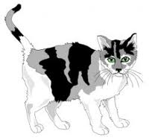 | 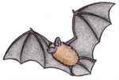  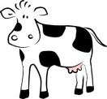
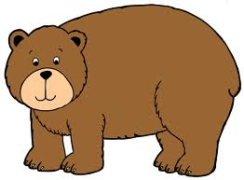 | 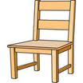  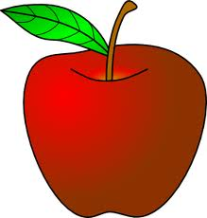
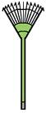 | 